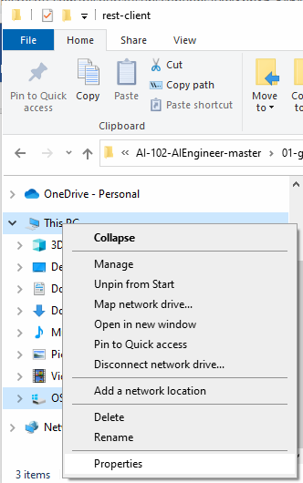

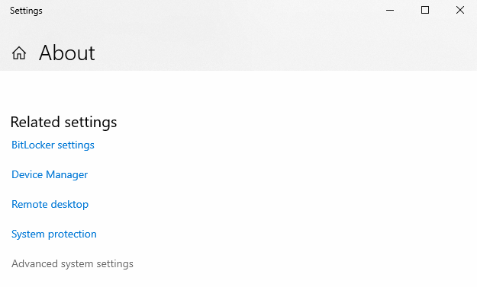

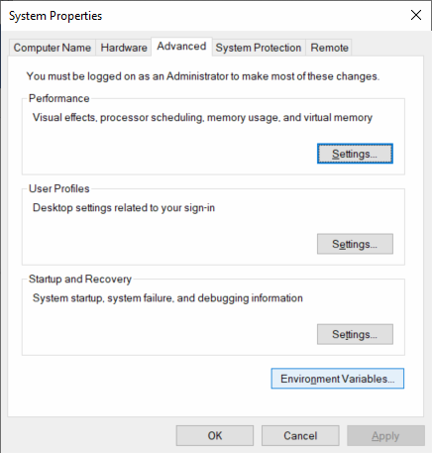

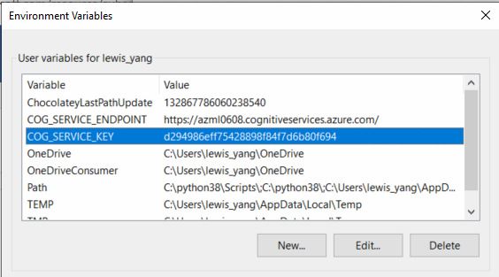

重新啟動視窗

c:\python>ipython

Python 3.8.8 (tags/v3.8.8:024d805, Feb 19 2021, 13:18:16) [MSC v.1928 64 bit (AMD64)]

Type 'copyright', 'credits' or 'license' for more information

IPython 7.27.0 -- An enhanced Interactive Python. Type '?' for help.

In [1]: import os

In [2]: os.getenv('COG_SERVICE_ENDPOINT')

Out[2]: 'https://azml0608.cognitiveservices.azure.com/'

In [3]:

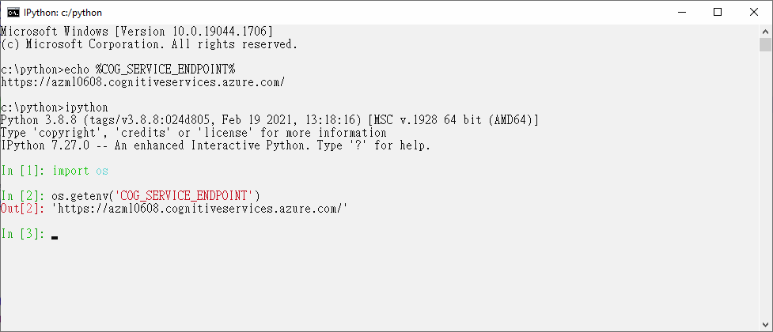

LINUX MAC 環境變數

export COG_SERVICE_ENDPOINT='https://azml0608.cognitiveservices.azure.com/'

echo $COG_SERVICE_ENDPOINT



Python 2.6.6 (r266:84292, Nov 21 2013, 10:50:32)

[GCC 4.4.7 20120313 (Red Hat 4.4.7-4)] on linux2

Type "help", "copyright", "credits" or "license" for more information.

>>> import os

>>> os.getenv('COG_SERVICE_ENDPOINT')

'https://azml0608.cognitiveservices.azure.com/'

>>>